NAME: RAJA RAYYAN AMEER
REG. NO.: 23-CP-25
SECTION: ALPHA
SUBJECT: DATABASE MANAGEMENT SYSTEM
DEPARTMENT: COMPUTER ENGINEERING
TEACHER: SIR SHAHID
LAB 1
Task 1: Install DBMS and GUI Tool
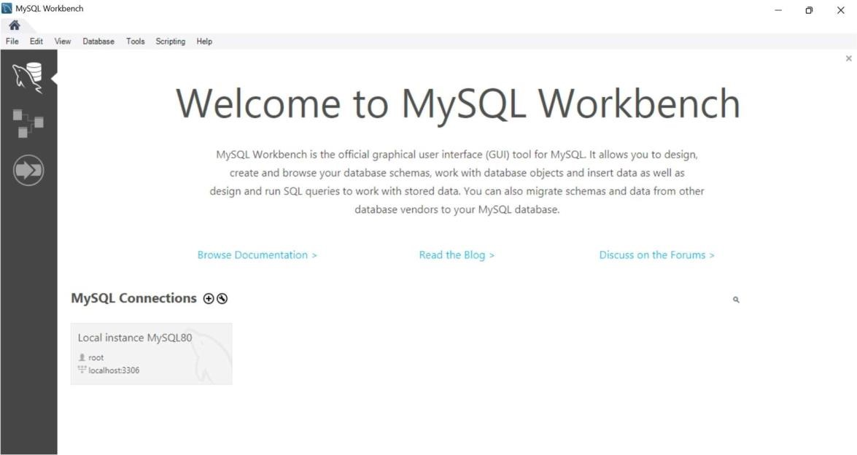
Task 2: Create a Database
Query:
CREATE DATABASE COLLEGE;
USE COLLEGE;
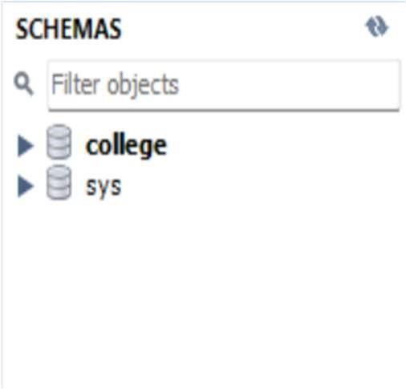
Task 3: Create the 'students' Table
Query:
CREATE TABLE Students (
student_id INT PRIMARY KEY, name VARCHAR(100),
dob DATE,
program VARCHAR(50)
);
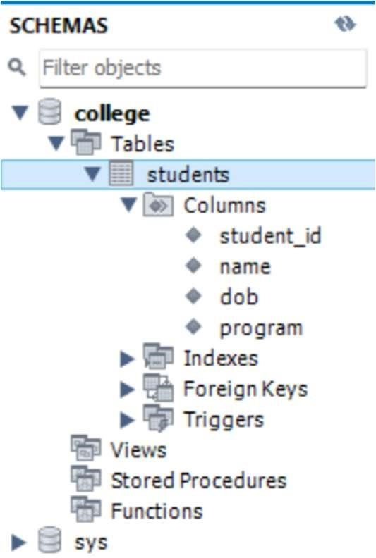
Task 4: Create 'courses' and 'enrolments’ Tables
Query:
CREATE TABLE courses (
course_id VARCHAR(10) PRIMARY KEY , title VARCHAR(100),
credit_hours INT
);
CREATE TABLE enrollments (
course_id VARCHAR(10),
semester VARCHAR(10),
PRIMARY KEY(student_id, course_id),
FOREIGN KEY(student_id) REFERENCES students(student_id),
FOREIGN KEY(course_id) REFERENCES courses(course_id)
);
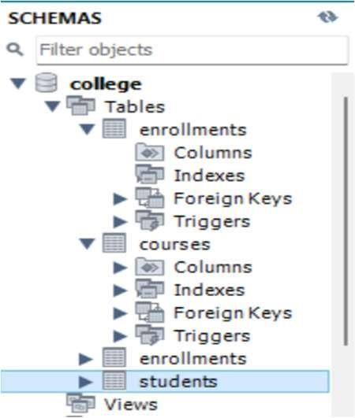
Task 5: Insert Sample Records
Query:
INSERT INTO students VALUES (1, 'Ali khan', '2000-05-12', 'Computer Engineering');
INSERT INTO students VALUES (2, 'Sara Ahmed', '2001-09-23', 'Software Enginnering');
INSERT INTO courses VALUES ('CS101','Databases',3);
INSERT INTO courses VALUES ('CS102','Programming',4);
INSERT INTO enrollments VALUES (1,'CS101','Fall2023');
INSERT INTO enrollments VALUES(2,'CS102','Fall2023');
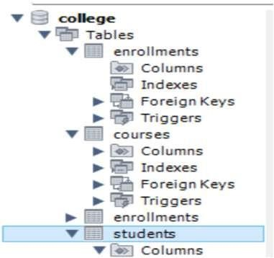
Task 6: Query All Students
Query:
SELECT * FROM students;
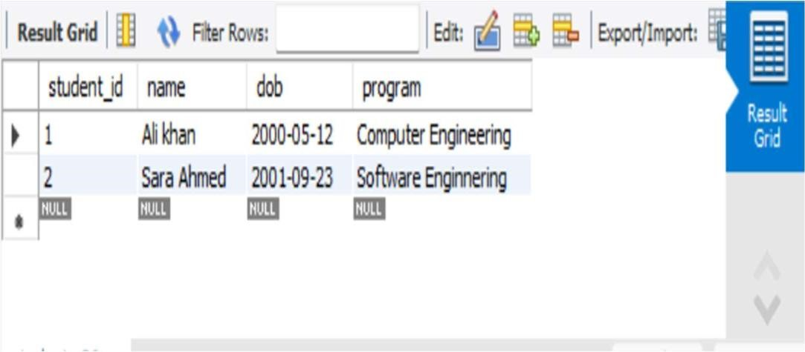
Task 7: Join Tables to Show Enrolments
Query:
SELECT s.name, c.title, e.semester
FROM students s JOIN enrollments e ON s.student_id = e.student_id
JOIN courses c ON e.course_id=c.course_id;
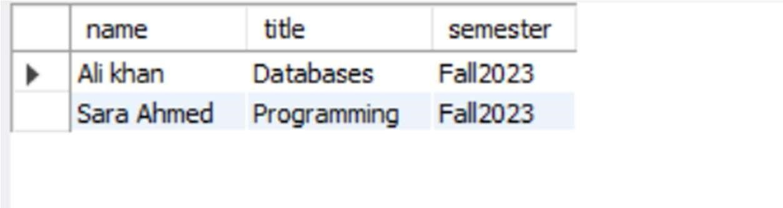
Task 8: View Structure in GUI
Query:
DESCRIBE students;
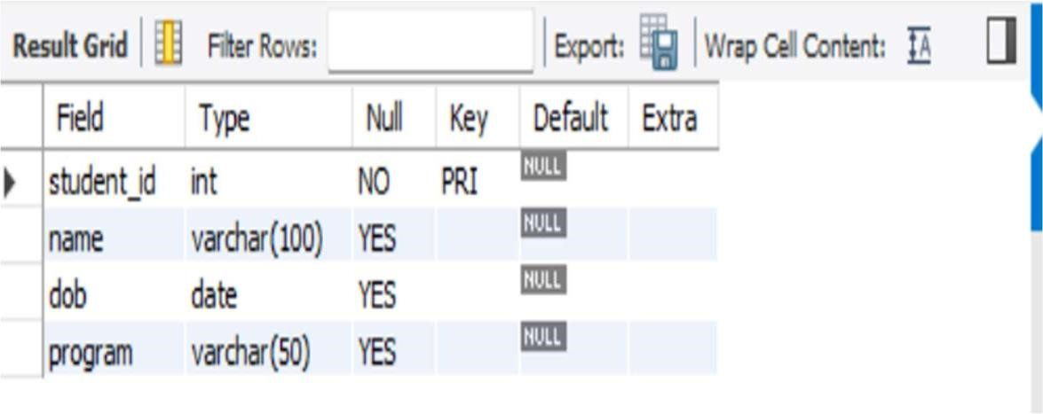
Task 9: Alter Table – Add Column
Query:
ALTER TABLE students ADD email VARCHAR(100) ;
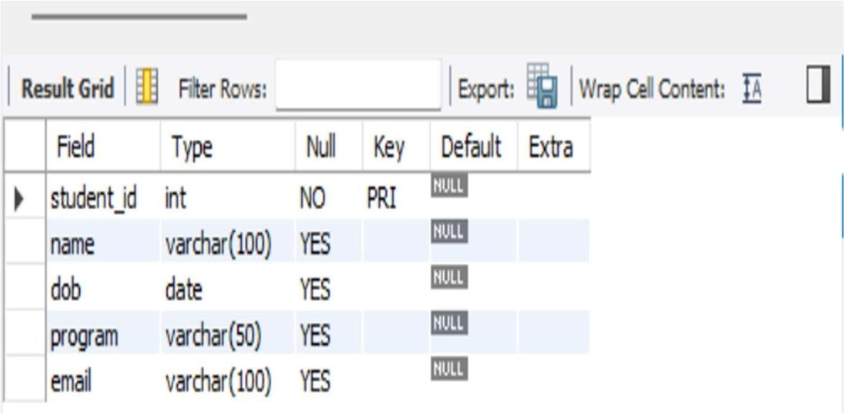
Task 10: Drop a Column
Query:
ALTER TABLE students DROP COLUMN email;
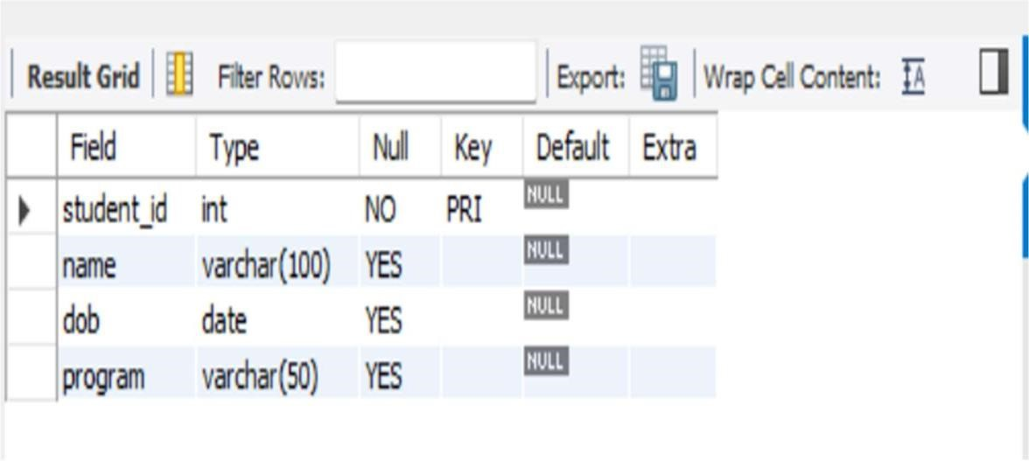
Challenge Tasks:
Task 1: Add a UNIQUE constraint on the email column in 'students'.
Query:
ALTER TABLE students ADD email VARCHAR(100) UNIQUE;
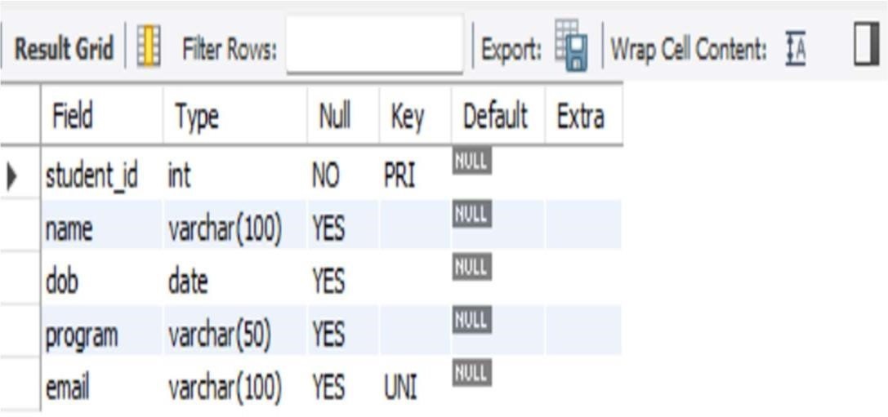
Task 2: Create a table 'departments' with dept_id and dept_name, and link it to 'students'.
Query:
CREATE TABLE departments (
dept_id VARCHAR(10) PRIMARY KEY, dept_name VARCHAR(100)
);
ALTER TABLE students
ADD COLUMN dept_id VARCHAR(10),
ADD FOREIGN KEY (dept_id) REFERENCES
departments(dept_id); SELECT s.student_id, d.dept_name
FROM students s
JOIN departments d ON s.dept_id = d.dept_id;
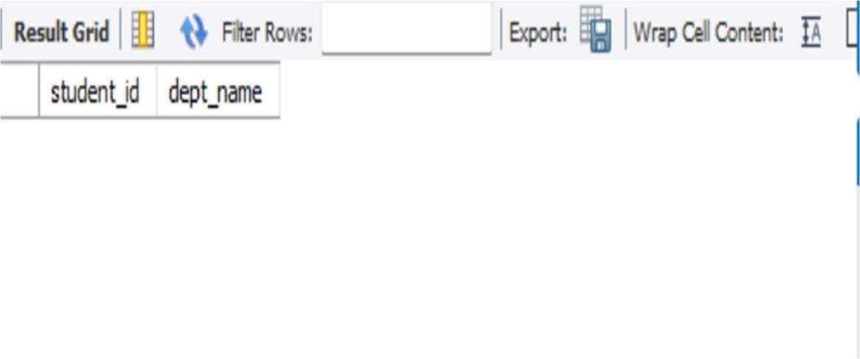
Task 3: Attempt to delete a course that is referenced in 'enrolments’ and record the error.
Query:
DELETE FROM courses WHERE course_id = "CS101";
Task 4: Update the 'program' of a student and display updated data.
Query:
UPDATE students
SET program = 'Civil
Engineering' WHERE student_id = 1;
SELECT * FROM students;
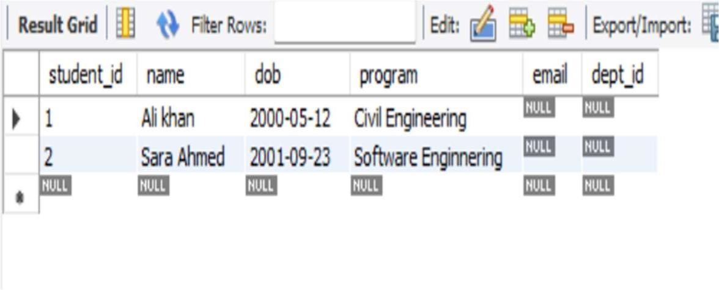
Task 5: Write a query that shows how many students are in each program (GROUP BY).
Query:
SELECT program, COUNT(*) AS student_count FROM students
GROUP BY program;
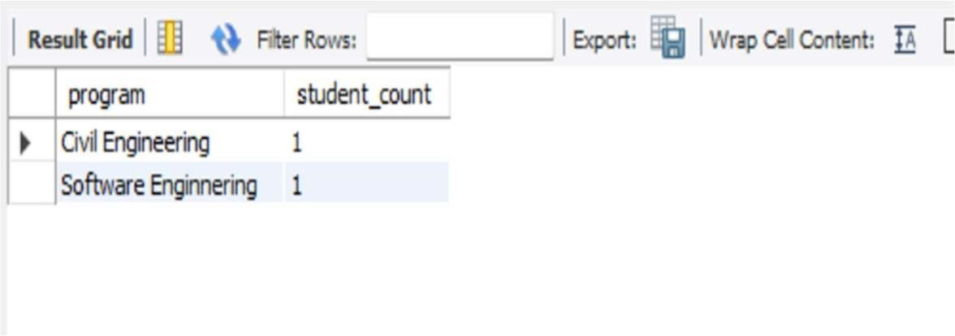

THE END

